**Use case diagram**

**Q.1 Use case diagram for ATM System?**

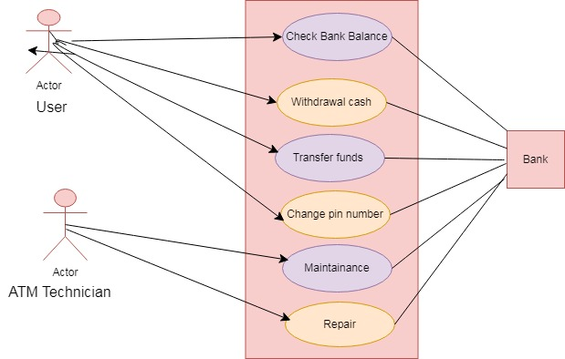

**Q.2 Use case diagram for ATM Cash Withdrawal System?**

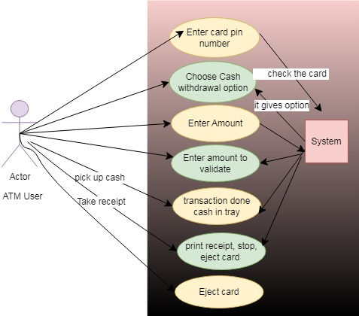

**Q.3 Online Video Conferencing System?**

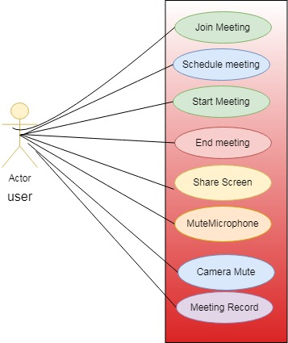

**Q.4 Flight Reservation System?**

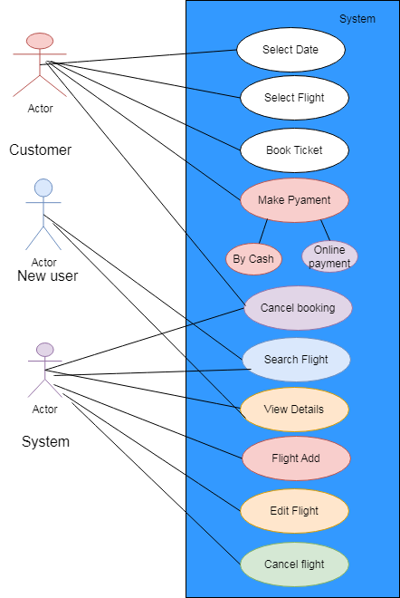

**Q.5 Online Pizza Order System?**

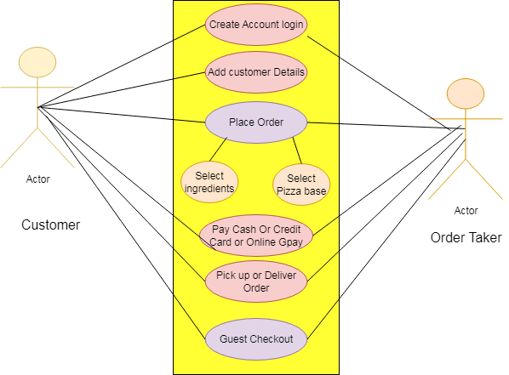

**Q.6 Online Buying Mobile?**

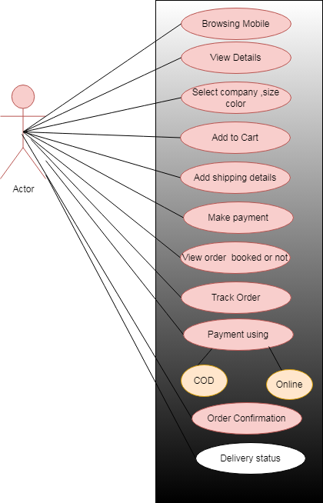

**Q.7 Student Admission Process?**

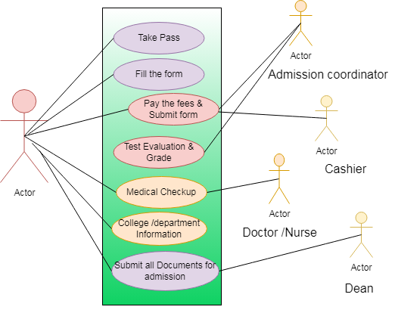

**Q.8 Restaurant Management?**

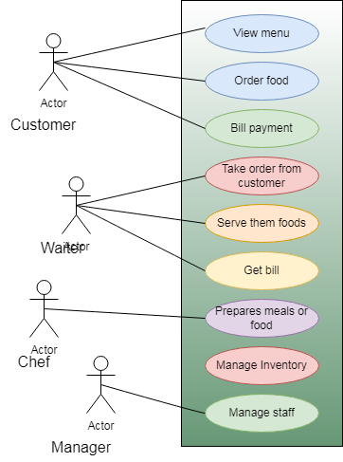

**Q.9 Online Shoes Buying?**

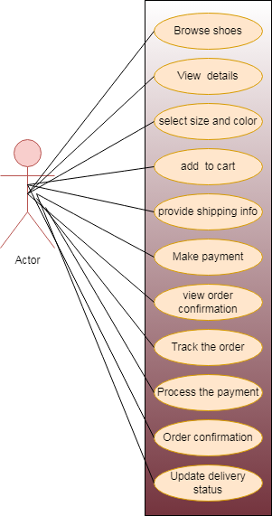

**Q.10 Online Movie Ticket booking System?**

